
A Capstone Project presented to The Faculty on Information Technology Department of MADRIDEJOS COMMUNITY COLLEGE, Bunakan, Madridejos, Cebu.

A Web-Based Platform for Streamlined Clearance and Certificate Processing of Barangay Pili

In Partial Fulfillment
of the Requirements for the Subject
Capstone Project 1

Presented by:
Janey Boljoran
Rose Marie D. Despi
Paul Gercan
Ronel Alolod

CHAPTER I
INTRODUCTION
Background of the Study
Barangays play a vital role in delivering essential public services to their constituents, including the issuance of clearances and certificates that serve as proof of residency, identity, and good standing within the community. These documents are often required for employment, education, business, and other legal purposes. However, the traditional manual system of processing such requests in Barangay PILI has presented several challenges, including long queues, incomplete records, delays in processing, and limited personnel to handle the growing demand.
In many cases, residents are required to visit the barangay office multiple times to follow up on their applications, which leads to inconvenience and inefficiency. Manual documentation also increases the risk of errors, duplication, and data loss, making it difficult for barangay officials to generate accurate reports and manage records effectively. These issues hinder the barangay’s ability to provide timely and reliable public service.
To address these concerns, the researchers proposed the development of a A Web-Based Platform for Streamlined Clearance and Certificate Processing of Barangay PILI. The system aims to automate the processing of clearances and certificates, improve record management, and provide residents with a convenient and efficient way to access services. Through this platform, residents will be able to submit requests, track application statuses, and receive documents online, reducing the need for repeated visits to the barangay office.
The proposed system is expected to enhance transparency, accountability, and operational efficiency within Barangay PILI. By digitizing clearance and certificate processing, barangay officials can minimize errors, reduce processing time, and strengthen trust between the community and local authorities. Ultimately, this initiative seeks to improve public service delivery and promote greater civic engagement among residents.

Objective of the Study
General Objectives
This study aims to develop a web-based platform for streamlined clearance and certificate processing of Barangay PILI.
Specifically, it aims to:

1. Provide CRUD (Create, Read, Update, and Delete) functionalities for the administrator to manage the following:
a). Resident Information – create, view, update, archive/restore resident records.
b). Certificate Types – create, view, update, and delete certificate and clearance types, including fees, processing days, and requirements.
c). User Accounts – create, view, update, archive/suspend, and restore user accounts.
d). Barangay Officials' Information – create, view, update, and archive officials' records.
e). Requests Management – view, update request status (pending, processing, approved, rejected, released), and archive completed or cancelled requests.
f). Summon/Blotter and Services – create or add summon request for residents, update status (pending, scheduled, resolved, cancelled).
2. Display on the dashboard the following:
a) Total Registered Residents
b) Total Requests
c) Total Pending Requests
d) Total Approved Requests
e) Total Monthly Requests
f) Request by Type
g) Recent Request
3. Provide the following system functions:
a). Generate and print monthly transaction reports that summarize issued barangay clearances and certificates, total transactions, total collections, and certificate type.
b). Allow residents to request barangay clearances and certificates.
c). Allow residents to view the status of their requests.
d). Display guidelines and requirements for requesting barangay clearances and certificates.
4. Develop a mobile application version of the system to improve accessibility and allow users to conveniently access the platform using mobile devices

5. Integrate SMS notification functionality into the system to provide residents with real-time updates on the status of their requests, reminders, and important barangay announcements.

6. Evaluate the developed system based on the ISO/IEC 25010 Software Quality Standards in terms of functional suitability, performance efficiency, usability, reliability, security, and maintainability.
Scope and Limitation

Scopes
This study focuses on the development of a Web-Based Platform for Streamlined Clearance and Certificate Processing of Barangay PILI. The system is designed to improve the efficiency of processing barangay clearances and certificates through digitalization.

Admin Side
1.Login Page – A page where system administrators enter their credentials to securely access and manage the system.
2.Dashboard – Displays an overview of system data including total residents, total requests, pending requests, approved requests, released requests, monthly requests chart, requests by certificate type chart, and a list of recent requests.
3.Requests Management – A page where all clearance and certificate requests submitted by residents are listed. Administrators can review, approve, reject, mark as processing, or release requests, and add remarks.
4.Residents Information – A page where the administrator can manage resident records, including viewing, verifying/approving new resident registrations, updating, and archiving resident information.
5.Certificate Types – A page where the administrator can add, edit, and manage the types of certificates and clearances available for request, including their fees, processing days, and requirements.
6.Reports – A page where the administrator can generate, view, and print monthly transaction reports. Reports include total transactions, total collections, and a breakdown by certificate type. Reports can also be exported as CSV.
7.Archive – A page where inactive or soft-deleted records (residents, requests, certificates, and users) are stored and can be restored when needed.
8. User Management – A page where the administrator manages system user accounts, including creating new users, approving pending accounts, and archiving/suspending users.
9. Officials Management – A page where the officials can update their personal information, change their password, and manage their profile photo.
10. Activity Logs - A page where all user actions within the system are recorded and viewable, including login/logout events, approvals, rejections, and profile updates. Logs can be filtered by module and activity type.

Resident Side
1. Registration and Login – Residents can register an account by providing personal information and credentials. Accounts require administrator approval before access is granted. Existing users can log in securely.
2. Requests – A page where residents can view all their submitted requests, including tracking numbers, document type, purpose, fee, payment status, filing date, and status.
3. New Request – A page where residents can submit a request for a specific barangay clearance or certificate, select the document type, and provide the purpose. Payment is processed in-person at the Barangay Office.
4. Profile Management – Residents can update their personal information, change their password, and manage their profile photo.

Limitations
1.The system requires internet access, which may limit usability for residents without stable connectivity.
2.The platform is designed specifically for Barangay PILI; therefore, it may not be directly applicable to other barangays without modification.
3.The system does not include integration with external government databases.
4.Resident who are not familiar with digital platforms may require assistance in using the system.
5.Payment for requested documents is processed exclusively in-person at the Barangay Pili Office. Online payment is not supported.
6.Issued certificates and clearances must be physically claimed at the Barangay Pili Office. Electronic delivery or download of documents is not available.
7.The system does not send automated email or SMS notifications to residents regarding the status of their requests.
8.Report generation is limited to monthly transactions only. Daily or weekly report breakdowns are not available in the current version.

Significance of the Study
This study will benefit the following:
Barangay Officials – The system will help improve efficiency in processing requests, reduce paperwork, and enhance record management.
Residents – The platform significantly improves the document requesting experience for residents of Barangay Pili. Through the online request portal, residents can submit applications for clearances and certificates at any time without physically visiting the barangay hall.
Barangay PILI Community – The platform contributes to the digital transformation of Barangay Pili's public service delivery. By streamlining the clearance and certification process, the system reduces delays, minimizes paperwork, and promotes transparency in barangay operations.
Future Researchers – This study may serve as a reference for future system development related to local government digitalization.

Definition of Terms
To help in understanding this study, the following terms are operationally defined:
Administrator
Conceptually, an individual who has authority to manage, supervise, and control system operations within an organization. Operationally, the administrator refers to the barangay personnel who manage the system, process requests, approve or reject applications, and maintain records.
Dashboard
Conceptually, it is an interface that displays summarized data through visual elements such as charts and figures for quick monitoring. Operationally, it shows the total number of residents, pending requests, approved requests, rejected requests, and completed transactions within the system.
Web-Based Platform
Conceptually, a system that operates over the internet and can be accessed using web browsers without installing software. Operationally, it refers to the online system developed for Barangay PILI that allows users and administrators to access and process clearance and certificate requests.
New Request
Conceptually, a formal action is made by a resident to obtain a service or document. Operationally, it refers to the submission of applications for barangay clearance, indigency, residency, and other certificates through the system.
Certificate Processing
Conceptually, a procedure of reviewing, verifying, and issuing official documents. Operationally, it refers to the system function that allows administrators to evaluate requests and generate approved certificates.

Report
Conceptually, a structured document containing collected data and analysis. Operationally, it refers to the generate, view, and print monthly transaction reports. Reports can also be exported as CSV.

Resident
Conceptually, a person who lives in a specific locality. Operationally, it refers to individuals residing in Barangay PILI who are eligible to request barangay clearances and certificates.
System
Conceptually, an organized set of components designed to perform specific functions. Operationally, it refers to the developed web-based platform used for managing clearance and certificate processing.

Conceptual Framework
The conceptual framework of the study presents the overall structure and flow proposed A Web-Based Platform for Streamlined Clearance and Certificate Processing of Barangay PILI. It illustrates the relationship between the inputs, processes, and outputs involved in the development and implementation of the system.

Figure 1. Conceptual Framework of the Study.
The Web-Based Barangay Clearance and Certificate System operates through a structured IPO flow. The input consists of resident registration data, clearance and certificate requests, request details, and administrative records, supported by guidelines and requirements. These are processed through the system’s processes, which include dashboard analytics, CRUD resident management, request validation and approval, report generation, authentication, and portal access for residents. The output is the production of digitally generated and printable barangay clearance certificates, monthly transaction reports, request status updates, and accessible guidelines. Ultimately, the outcome is a streamlined, transparent, and efficient clearance issuance process that reduces manual workload, ensures accurate reporting, improves resident satisfaction, and strengthens trust in barangay governance.

CHAPTER II
RELATED LITERATURE AND PRIOR ARTS
Digital transformation has significantly improved the efficiency of public service delivery in local government units. According to Shivtarkar (2023), web-based administrative systems streamline traditional processes by digitizing records, automating transactions, and providing online access to government services. These systems reduce paperwork, minimize processing delays, and improve data accuracy, making public services more accessible to citizens.
The adoption of e-governance systems has become essential for improving transparency and accountability in government operations. According to the United Nations E-Government Survey (2022), digital government platforms enable citizens to access services more efficiently while enhancing communication between government offices and the public. Such systems contribute to better service management and increased public trust.
Resident information management systems have been widely implemented to organize citizen records effectively. Research by Kumar and Singh (2021) found that centralized databases improve data retrieval speed, reduce duplication of records, and support decision-making processes in local government offices. Efficient resident data management also facilitates faster verification during document processing.
According to Al-Hujran et al. (2021), online government service platforms improve service accessibility by allowing citizens to submit requests and monitor transaction statuses remotely. These systems reduce the need for repeated office visits and help government personnel manage requests more systematically.
Document management systems play a crucial role in handling certificates, permits, and official clearances. A study conducted by Rahman and Islam (2022) revealed that digital document processing significantly reduces administrative workload and processing time while improving record security and accessibility. Automated workflows also help ensure consistency in document issuance.
Dashboard technologies have become valuable tools for monitoring organizational performance and service transactions. Few (2020) emphasized that dashboards provide visual summaries of key information, enabling administrators to track requests, monitor pending transactions, and make informed decisions based on real-time data. Such features improve operational efficiency and oversight.
Report generation is another important feature of information systems. According to O’Brien and Marakas (2021), automated reporting tools enhance organizational decision-making by providing accurate and timely summaries of transactions and activities. Monthly transaction reports allow administrators to monitor service demand, evaluate performance, and maintain accountability.
User management and access control are essential components of web-based systems. Stallings (2021) explained that secure authentication and authorization mechanisms help protect sensitive information by ensuring that only authorized users can access specific system functions. Proper user management contributes to system security and data integrity.
Activity logging is widely recognized as an important feature for monitoring system usage and ensuring accountability. According to Kim and Solomon (2022), activity logs provide a record of user actions, enabling administrators to track system activities, investigate issues, and detect unauthorized access. Logging mechanisms strengthen system transparency and auditability.
Furthermore, citizen-centered service platforms have demonstrated positive impacts on public service delivery. A study by Ahmad and Abu Talib (2024) found that digital service systems improve citizen satisfaction by providing convenient access to government services, reducing waiting times, and increasing the efficiency of administrative processes. The findings support the development of web-based solutions for local government service management.
The reviewed literature indicates that web-based information systems enhance efficiency, transparency, data management, and service delivery in government institutions. These studies provide a strong foundation for the development of the proposed Web-Based Platform for Streamlined Clearance and Certificate Processing of Barangay Pili

Prior Arts and Reference Systems
NBI Clearance Online Registration and Application Services
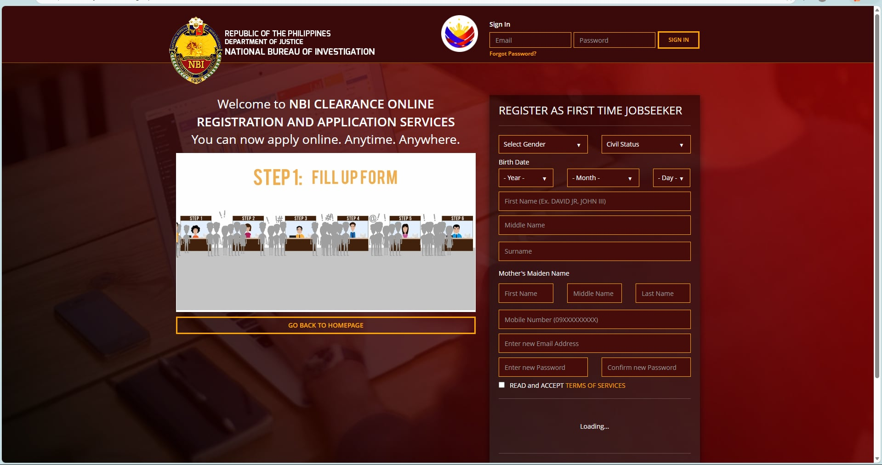
Source : https://firsttimejobseekers.nbi.gov.ph/
The Prior Art presents a centralized and organized interface in a linear formation, guiding users through the initial step of the clearance process. At the top, the form highlights the option to register as a first-time jobseeker, ensuring clarity of purpose. Below this, personal information fields are systematically arranged into overview sections such as gender, civil status, birth date, name details, mother’s maiden name, mobile number, and email address. Password creation and acceptance of terms of service are positioned at the end, completing the logical flow.

Figure 2. Baranggay Pili Online Clearance Registration page
Similar to the Prior Art,the Barangay Pili Streamlined Clearance and Certificate system presents a centralized registration interface in a linear and organized formation, designed to simplify the onboarding process for residents. At the top, the form welcomes users with a “Welcome Back” panel, clearly distinguishing between registration and login options. Below, personal information fields are systematically arranged into overview sections such as first name, last name, middle name, gender, civil status, complete address, postal code, residency name, email address, and password creation. Action buttons for “Register” and “Create Account” are positioned at the end, completing the logical flow. On the left, a service panel highlights available offerings including Barangay Clearance, Vehicle Certificate, Business Clearance, Real-Time Document Tracking, and other documents, reinforcing transparency and accessibility. This structured layout ensures that residents can easily navigate the registration process, while the vibrant background design reflects community identity and engagement.
System Adoption and Registration Report
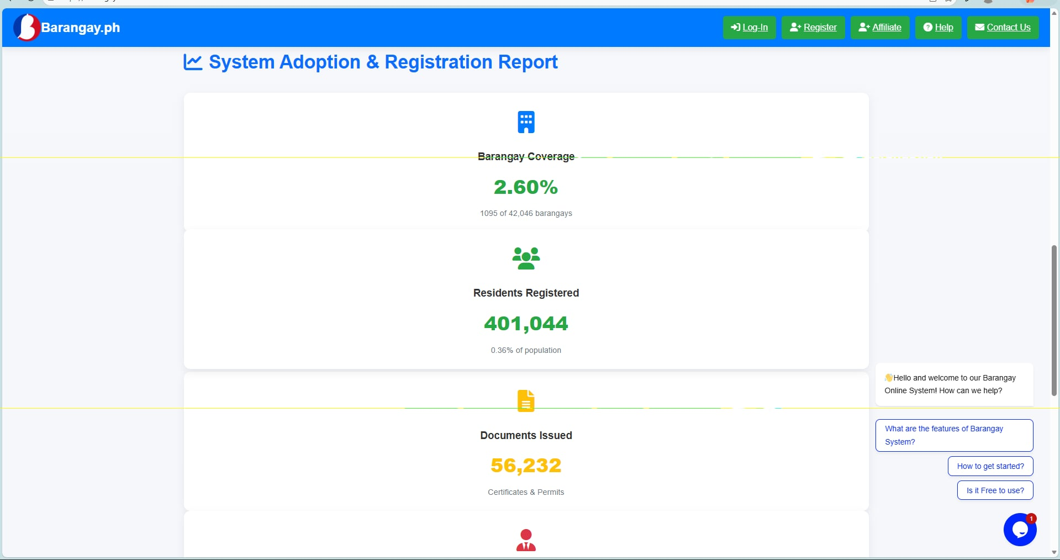Source: https://barangayonline.com/
The Prior Art presents the Barangay.ph System Adoption & Registration Report presents a centralized transparency dashboard in a linear and organized formation, designed to highlight adoption metrics and system performance. At the top, navigation options such as Log-In, Register, Affiliate, Help, and Contact Us provide clear entry points for users. Below, statistical overview cards display key indicators: barangay coverage, residents registered, and documents issued. Each card presents both raw counts and percentage values, ensuring clarity and comparability. On the right, an interactive chat box welcomes users and offers guided prompts such as system features, getting started, and usage costs, enhancing accessibility and user support. This structured layout allows stakeholders to easily monitor progress, evaluate adoption rates, and understand the scope of digital transformation across barangays, reinforcing transparency and accountability.

Figure 3. Baranggay Pili Admin Dashboard
Similar to the Prior Art, the Resident Request Dashboard presents a centralized and organized interface in a linear formation, designed to provide administrators with a clear overview of community transactions. At the top, numerical statistics summarize total residents, total requests, pending requests, approved requests, and released documents, offering immediate insight into system activity. Below, visual charts display monthly requests and requests by type, allowing trends and distribution to be easily understood. On the right, a recent requests table lists tracking numbers, resident names, document types, and current statuses, ensuring transparency and traceability of individual applications. This structured layout enhances efficiency by combining quantitative metrics, graphical summaries, and detailed records in one cohesive view, making the clearance process more accessible and accountable.

BaranggayOS Application form
Source: https://barangayos.com/
The Prior Art presents the BarangayOS system presents a centralized digital interface in a linear and organized formation, streamlining the core functions of barangay services. At the top, the platform emphasizes accessibility with the tagline “Your barangay, at your fingertips,” clearly communicating its purpose. Below, three structured sections guide the user: Request Documents Instantly, where residents can submit applications through a simple form; Track in Real-Time, which displays the progress of requests across stages such as received, in review, for release, and released; and Pay with E-Wallets, offering secure payment options through GCash and Maya. Complementing these, an integrated SMS & Email Notifications feature ensures residents are updated on their request status without needing to revisit the barangay hall. This organized layout enhances transparency, efficiency, and convenience, making administrative processes more accessible to the community.

Figure 4. Clearance request Form.
Similar to the Prior Art,The Barangay Pili Online Document Request Form presents a centralized and organized interface in a linear formation, designed to streamline the process of requesting official documents. At the top, payment information is clearly stated, reminding users that transactions are processed at the barangay office. Below, the system provides structured options under Select Document to Request, with clear details on fees and processing times for Barangay Clearance, Certificate of Indigency, and Certificate of Residency. The Requirements section ensures transparency by listing necessary documents such as valid ID and proof of indigency. A dedicated field for Purpose/Reason allows applicants to specify their intent, with suggestions provided for accuracy. At the bottom, navigation buttons for “Back” and “Submit Request” complete the logical flow. This organized layout enhances efficiency, guiding residents through each step while maintaining clarity and accountability in the request process.
Baranggay Clearance online

Source: https://policeclearanceonline.com.ph/barangay-clearance-guide/
The Prior Art presents a The Barangay Clearance Requirements and Application Guide presents a centralized and organized interface in a linear formation, designed to inform users about the process of obtaining clearance certificates. At the top, navigation links such as Police Clearance, Online Appointment, Required Documents, Clearance Sample, and Contact Us provide structured entry points for related services. The main banner highlights the purpose of the page, while a sample Barangay Clearance document is displayed on the right, complete with official seals and certification details to reinforce authenticity. Supporting text outlines requirements, fees, and procedural steps, ensuring transparency and accessibility for applicants. This structured layout enhances clarity by combining official references, procedural guidance, and visual samples, making the clearance process easier to understand and follow.

Figure 5. Baranggay Pili Sample Clearance
Similar to the Prior Art The Barangay Clearance document presents a standardized and organized format in a linear formation, designed to certify an individual’s residency and good standing within the community. At the top, official seals and headings establish authenticity and authority under the Office of the Punong Barangay. The main body of the clearance provides structured fields for the applicant’s name, address, and purpose, alongside a designated space for a photo, thumb-mark, and signature. Supporting attestations from the Punong Barangay, Secretary, and Treasurer reinforce accountability and transparency. On the left sidebar, the listing of barangay officials further contextualizes the document within local governance. This structured layout ensures clarity, legitimacy, and ease of verification, making the clearance an essential instrument for identification, employment, and community-level certification.

PNP Clearance login page

Source: https://pnpclearance.ph/signin
The Prior Art presents the National Police Clearance system presents a centralized login interface in a linear and organized formation, designed to streamline access for registered users. On the right, the login form provides structured fields for email and password, accompanied by options for signing in, password recovery, and new user registration. Above the form, clear instructions guide applicants who have already registered, ensuring ease of navigation. On the left, a visual panel reinforces the system’s identity, while official seals and footer credits at the bottom establish authenticity and authority. This structured layout enhances transparency and accessibility, allowing applicants to securely manage their clearance applications while maintaining clarity and accountability in the process.

Figure 6. Barrangay Pili Online Clearance Login Page
Similar to the Prior Art, The Barangay Pili Streamlined Clearance and Certificate system presents a centralized login interface in a linear and organized formation, designed to provide secure access for residents and administrators. On the right, the “Welcome Back” panel offers clear options to sign in or register, with structured fields for username or email and password, followed by a prominent sign-in button. On the left, a red information panel reinforces the system’s identity with the official seal and descriptive text, highlighting features such as Barangay Clearance, Vehicle Certificates, Real-Time Status Tracking, Print Documents, and Secure & Private services. Footer details including version information and location establish credibility and transparency. This structured layout enhances accessibility and efficiency, ensuring that users can securely manage their barangay transactions while maintaining clarity and trust in the system.
Certificate of Indigency of Baranggay Mambog

Source:https://www.scribd.com/document/739798404/Certificate-of-Indigency-2022-AICS
The Prior Art presents the Certificate of Indigency presents a standardized and organized format in a linear formation, designed to certify an individual’s economic status within the community. At the top, official seals and headings establish authenticity and authority under the Office of the Barangay Captain. The main body of the certificate provides structured fields for the resident’s name, address, and confirmation of indigency, ensuring clarity and legitimacy. Supporting attestations from the Punong Barangay reinforce accountability and transparency, while the sidebar listing barangay officials situates the document within the framework of local governance. This structured layout enhances credibility and accessibility, making the certificate an essential instrument for residents seeking social assistance, scholarships, or government support programs.

Figure 7. Generated Certificate of Indigency
Similar to the Prior Art the Certificate of Indigency presents a standardized and organized format in a linear formation, designed to certify an individual’s indigent status within the community. At the top, official seals and headings establish authenticity and authority under the Office of the Barangay Captain. The main body of the certificate provides structured fields for the resident’s name, address, and confirmation of indigency, ensuring clarity and legitimacy. Supporting attestations from the Barangay Captain reinforce accountability and transparency, while the sidebar listing barangay officials situates the document within the framework of local governance. This structured layout enhances credibility and accessibility, making the certificate an essential instrument for residents seeking social assistance, scholarships, or government support programs.
Public Attorneys Office

Source:https://www.foi.gov.ph/requests/request-for-a-certificate-of-indigency/
The Prior Art presents the Public Attorneys Office (PAO) Online Request System presents a centralized and organized interface in a linear formation, designed to streamline the process of submitting and tracking service requests. At the top, the system highlights the progress flow with four clear stages: Request Submitted, Processing Request, Request Successful, and Rate Your Request, ensuring transparency at every step. The highlighted section confirms successful completion, while detailed request information such as tracking number, date requested, date responded, and status provides accountability. Supporting options like “Print Conversation” and “Share this Request” enhance accessibility and documentation. This structured layout combines progress indicators, request details, and feedback mechanisms, making the process efficient, transparent, and user-friendly for residents seeking legal or administrative assistance.

Figure 8. Tracking certificate Request.
Similar to the Prior Art The Barangay Pili Request Tracking System presents a centralized and organized interface in a linear formation, designed to provide transparency and accountability in monitoring document requests. At the top, the system displays essential request details such as tracking number, document type, session ID, request date, payment amount, and current status, ensuring clarity for the applicant. Below, a structured progress flow highlights stages including Request Submitted, Under Review, Approved, and Ready for Release, allowing residents to follow the lifecycle of their application. The pending status is clearly indicated, reinforcing accuracy and real-time monitoring. This structured layout enhances efficiency by combining request metadata with progress indicators, making the clearance process more accessible, traceable, and user-friendly for both residents and administrators.
Profile Management

Source:https://support.phorest.com/hc/enus/articles/360007972614-How-do-I-set-up-PIN-codes-Access-Levels-forstaff-members
The Prior Art presents the Staff Profile Form presents a centralized and organized interface in a linear formation, designed to capture both personal and professional details of employees. On the left, a sidebar menu provides structured navigation options such as Details, Settings, App Profile, Notes, Self Employed, Time Keeping, and Video Calls, ensuring accessibility to related functions. The main section arranges input fields systematically, including first name, last name, staff category, access level, email, phone number, system PIN, birth date, start date, and address details. A highlighted “Send PIN” feature reinforces security and system verification. This structured layout enhances clarity and efficiency by combining identity information, employment details, and system access controls in one cohesive form, making staff management transparent and user-friendly.

Figure 9. Profile Management.
Similar to the Prior Art the User Profile Management system presents a centralized and organized interface in a linear formation, designed to allow residents or users to manage their personal information securely. At the top, the profile section displays a photo, username, and account details such as location, contact number, date of birth, and age, establishing identity and context. Below, the interface is divided into two structured panels: Edit Profile, which provides fields for first name, last name, middle name, contact number, address, and occupation, ensuring that personal data can be updated accurately; and Change Password, which offers fields for current password, new password, and confirmation, reinforcing account security. Supporting features like photo upload and update options enhance personalization. This structured layout combines identity verification, editable information, and security controls, making the system transparent, user-friendly, and efficient for managing digital profiles.
Baranggay Official list in Poblacion 1

Source: https://www.scribd.com/document/706752153/8-BARANGAY-ORG-CHART
The Prior Art presents The Barangay Poblacion 1 Organizational Chart presents a structured and organized visual formation, designed to clearly outline leadership and support roles within the community. At the top, the Barangay Captain is prominently positioned, establishing authority and accountability. Below, the chart systematically arranges barangay kagawads, secretary, and treasurer, ensuring transparency in governance. A secondary chart highlights the Barangay Nutrition Scholar and Barangay Health Workers, reinforcing the integration of health and welfare services into local administration. Circular portraits paired with names and titles enhance recognition and legitimacy, while the dual chart format distinguishes governance from health-related functions. This structured layout provides clarity, accessibility, and accountability, making the organizational framework of Barangay Poblacion 1 easy to understand and reference.

Figure 10. Baranggay Officials.
Similar to the Prior Art the Barangay Officials Management Dashboard presents a centralized and organized interface in a linear formation, designed to streamline the administration of local government personnel. At the top, a prominent “Add Official” button enables quick inclusion of new members, reinforcing flexibility and scalability. Below, a grid layout displays profile cards for each barangay official, with circular placeholders, names prefixed by “HON.,” and positions labeled as Barangay Kagawad. Each card includes functional buttons for Edit, View, and Delete, ensuring transparency and control in managing records. This structured layout enhances efficiency by combining identity presentation with administrative tools, making the system user-friendly, accountable, and adaptable for barangay-level governance.
Baranggay360 User management

Source: https://barangay360.com/users
The Prior Art presents the Barangay360 User Management Dashboard presents a centralized and organized interface in a linear formation, designed to streamline the administration of system users and their roles. On the left, a sidebar provides structured navigation options such as Management, Programs & Events, Reports, Financial, Barangay Map, and Super Admin, ensuring accessibility to related modules. The main panel highlights User Management, displaying a tabular list of system users with details including name, email, position, contact, and assigned roles. Functional action icons for editing and deleting records reinforce accountability and control. A prominent “Add User” button at the top right enables quick inclusion of new accounts, ensuring scalability and adaptability. This structured layout enhances efficiency by combining identity presentation, role assignment, and administrative tools, making the system transparent, user-friendly, and effective for barangay-level governance.

Figure 11. User Management
Similar to the Prior Art The Barangay PILI User Management Dashboard presents a centralized and organized interface in a linear formation, designed to streamline the administration of resident and administrative accounts. On the left, a red sidebar provides structured navigation options such as Dashboard, Requests, Residents, Certificate Types, Officials, User Management, Archive, Reports, and Activity Logs, ensuring accessibility to related modules. The main panel highlights System Users, displaying a tabular list of accounts with details including email, role, linked resident, contact information, status, and creation date. Functional action options such as “Activate” or “Current Account” reinforce accountability and control in managing user access. The structured layout enhances efficiency by combining identity presentation, role assignment, and account status management, making the system transparent, user-friendly, and effective for barangay-level governance.

Complaints, Compliments and Feedback

Source: https://www.jotform.com/form-templates/complaints-compliments-and-feedback-form
This Prior art represent the Complaints, Compliments, and Feedback Form presents a centralized and organized interface in a linear formation, designed to streamline the collection of customer input. At the top, a structured panel introduces the form with a clear title, reinforcing its purpose as a feedback channel. Below, the main body arranges input fields systematically: a Feedback Type selector offering options for Complaint, Compliment, or General Feedback; a Date Reported or Discussed field ensuring chronological tracking; and personal identification fields such as First Name and Last Name. Contact preferences are captured through a dropdown labeled Best Contact Method for us to respond, complemented by a Phone Number entry for direct communication.

Figure 12. Digital KP Form No. 7 Management Interface
Similar to the traditional and web-based Prior Art, the Barangay PILI Case Filing and Complaint Dashboard presents a centralized, linear, and organized interface designed to streamline the administration of local disputes. On the left, the system's signature red sidebar provides structured navigation options—including Dashboard, Requests, Residents, Certificate Types, Officials, User Management, and Case Records—ensuring immediate accessibility to administrative modules. The main panel highlights the active legal instrument, displaying a tabular layout of KP Form No. 7 (Complaint Form) metadata, including distinct columns and sections for Complainant profiles, Respondent identities, and Case reference numbers. Functional action options such as "Print Document" and "Back to List" reinforce administrative control and document mobility. This structured layout enhances operational efficiency by combining legal document presentation, identity tracking, and dispute status management into a single, transparent, and user-friendly system optimized for barangay-level governance.
Borrow Items on Borrow Me

Source: https://www.jotform.com/form-templates/complaints-compliments-and-feedback-form
This Prior art represent the Borrow Me Tent Rental Search Page presents a centralized and organized interface in a linear formation, designed to streamline the discovery and reservation of event equipment. At the top, a structured navigation bar introduces categorical options such as Party & Events, Gaming, Image & Sound, Clothing, Kitchen, Sports & Holidays, Transport, Electronics, Health & Wellbeing, Appliances, Baby, Tools & Garden, and Pets, reinforcing accessibility across diverse rental categories.

Figure 13. Borrow Requests Management Interface
Similar to the traditional and web-based Prior Art, the Barangay Felicartance Borrow Requests Dashboard presents a centralized, linear, and organized interface designed to streamline the administration of community equipment lending. On the left, the system’s vertical sidebar provides structured navigation options—including Dashboard, Residents, Certificate Types, Officials, User Management, Archive, Activity Logs, and Logout—ensuring immediate accessibility to administrative modules.

SYNTHESIS OF THE STUDY
Barangay Pili does not currently have a confirmed standalone online barangay clearance portal, so most residents still process it at the Barangay Hall through the Barangay Secretary and Punong Barangay. If an online system were available, it would follow the common Philippine model: check availability via the barangay’s official Facebook page or municipal website, fill out an online form with personal details and purpose, upload requirements like a valid ID, proof of residency, and cedula, pay the fee of around ₱50-80 via GCash or cash walk in, and either pick up the document or receive a PDF with QR code. Standard requirements include the application form, 2 valid IDs, proof of residency for at least 6 months, cedula, and payment, with processing usually taking 15 minutes to 1 day under RA 11032. For now, the best approach is to contact Barangay Pili Hall directly to confirm if they accept online submissions, and avoid fixers since all official transactions should provide a receipt.

CHAPTER III
METHODOLOGY

REEARCH DESGIN
This chapter describes how the researchers went about building the Web-Based Platform for Streamlined Clearance and Certificate Processing of Barangay Pili. From the early planning stages all the way to deployment, the team followed the Rapid Application Development (RAD) model and borrowed several practices from Agile to keep things moving and on track.
The group settled on RAD because it puts a strong emphasis on building working prototypes early and getting feedback from actual users before moving forward. Given that the project had a tight timeline and needed to work well for people who are not necessarily tech savvy barangay officials, staff, and ordinary residents it made sense to go with a model that keeps users involved at every step. Adding Agile elements like short sprints, regular check-ins with stakeholders, and flexible planning helped the team adjust whenever new concerns or ideas came up during development.
This combination felt like the right fit for the project. The system has two different types of users (administrators and residents), each with their own set of features, and the modules range from request management and dashboard analytics to report generation and resident registration. On top of that, the end users at the barangay are not developers—so it was important to keep showing them working versions of the system and asking whether it actually made sense to them, rather than just building everything behind closed doors and hoping for the best.

Development Methodology: RAD with Agile Integration
The whole development process was broken down into six phases, following the RAD lifecycle. Each phase had specific goals and deliverables, and Agile practices were woven in wherever they could add value. Figure 2 below shows how the six phases connect to each other in a continuous cycle.
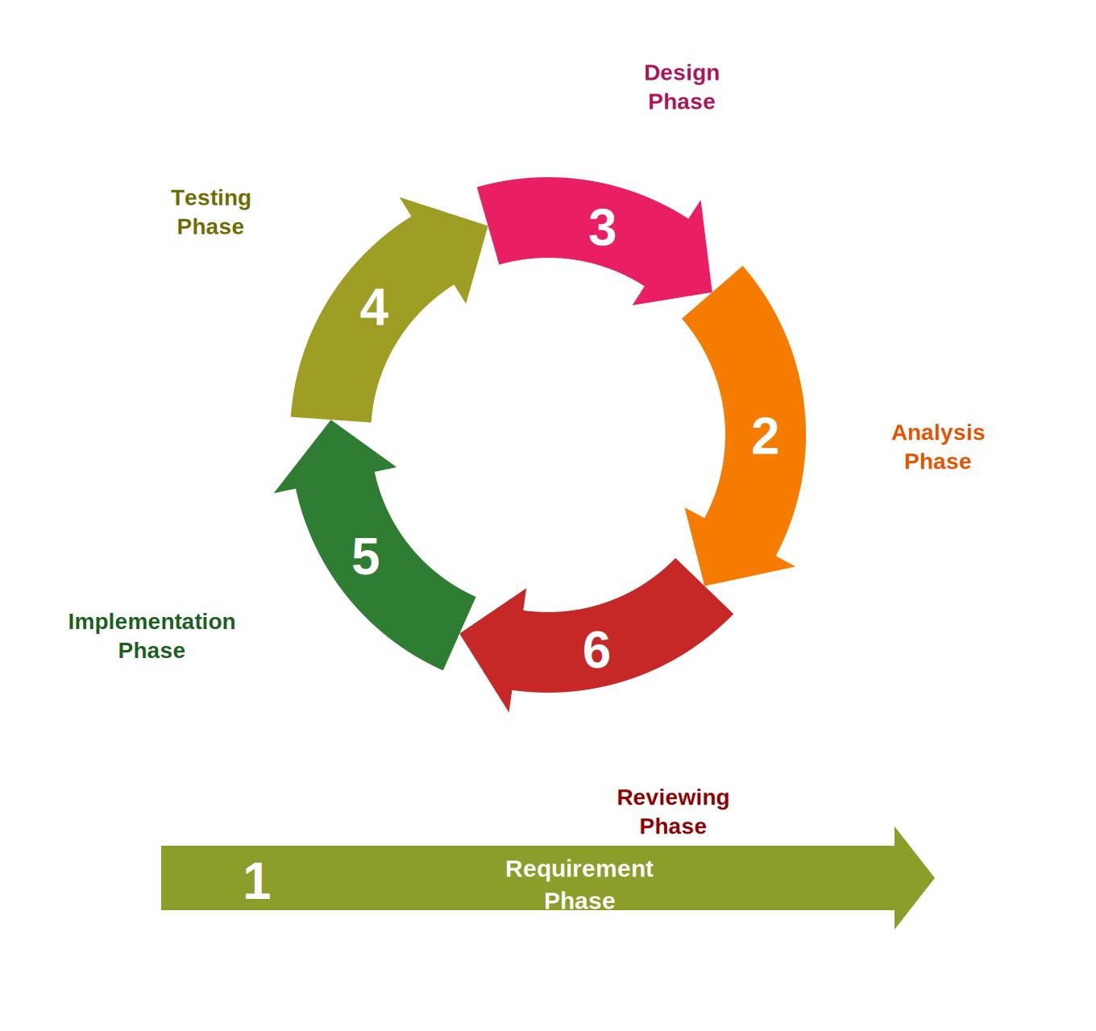
Figure 14. Rapid Application Development (RAD) Lifecycle Model

Phase 1: Requirement Phase
Before writing any code, the researchers first needed to understand what the system should actually do and what problems it was supposed to solve. This meant spending time at the Barangay Pili office, watching how staff currently handle clearance and certificate requests, and talking to the people involved in the process both the officials who process the paperwork and the residents who request documents.
During this phase, the team:
• Visited the barangay office several times to observe the day to day workflow and see firsthand where delays and bottlenecks happen.
• Sat down with barangay officials, staff members, and a number of residents to ask about their frustrations with the current process and what features they would want in a new system.
• Looked into related studies and existing systems used by other local government units to get a sense of what has worked elsewhere.
• Defined the project scope, laid out the objectives, identified the two main user roles (administrator and resident), and listed out the functional requirementsthings like CRUD operations, dashboard stats, reports, and request tracking.
• Put together a product backlog, which is basically a running list of all the features and tasks ranked by how important and doable they are.
By the end of this phase, the group had a clear picture of what the system needed to do and a prioritized list of features that would guide everything that followed.

Phase 2: Analysis Phase
Once the requirements were gathered, the next step was to make sense of all that information and figure out how the system should be structured. The team went through each requirement, checked whether it was feasible given the timeline and resources, and started mapping out how data would flow through the system.
Key activities in this phase included:
• Breaking down the current manual workflow step by step to pinpoint exactly which parts could be automated.
• Writing use cases and user stories for every module—essentially describing what each type of user would need to do and why.
• Identifying the main data entities (residents, requests, certificates, users, officials, logs) and how they relate to each other, which later fed into the database design.
• Running backlog grooming sessions where the team re-prioritized features based on what mattered most and what was realistic to build first.
• Documenting the functional specs for each module on both the admin side (Dashboard, Requests Management, Residents Info, Certificate Types, Reports, Archive, User Management, Officials Management, Activity Logs) and the resident side (Registration, Requests, New Request, Profile).

Phase 3: Design Phase
With the analysis done, the team moved on to designing what the system would look like and how it would work under the hood. This phase was heavily iterative rather than trying to nail down a perfect design on the first try, the researchers built rough versions, showed them to barangay stakeholders, gathered feedback, and revised. This cycle repeated several times in short sprints, usually lasting one to two weeks each.
Here is what the team worked on during this phase:
• Created wireframes and mockups for every screen in the system—both the admin panel and the resident-facing portal.
• Designed the Entity-Relationship Diagram (ERD) and mapped out the database schema, defining how tables for residents, requests, certificates, users, officials, and logs would connect.
• Built clickable prototypes and walked barangay officials and selected residents through them, asking for honest feedback on what made sense and what did not.
• Used the feedback from each round of review to tweak layouts, simplify navigation, adjust form fields, and improve how data was displayed.
• Finalized the technology stack deciding on the frontend framework, backend language, and database system the project would use.
The idea here was to let the design evolve based on real input from the people who would actually use the system, rather than guessing what they might want.

Phase 4: Testing Phase
Testing was not something the team saved for the end it happened throughout the entire development process. Every time a new feature was built, it was tested right away so that bugs and issues could be caught early, before they snowballed into bigger problems.
The testing approach had four layers:
Unit Testing – Each individual module and function was tested on its own. For example, the team checked whether each CRUD operation worked correctly, whether the login system handled valid and invalid credentials properly, and whether reports generated the right numbers.
Integration Testing – Once separate modules were working on their own, the team tested them together to make sure data flowed correctly from one part of the system to another like whether a resident's request actually showed up in the admin panel and eventually appeared in the monthly report.
System Testing – The entire system was tested as a whole to make sure everything worked together under realistic conditions, including checking how it performed when multiple users were logged in at the same time.
User Acceptance Testing (UAT) – Barangay officials and a group of residents tried out the system and gave their verdict on whether it met the objectives. An evaluation form was used to collect their ratings on things like functionality, ease of use, reliability, and speed.

Phase 5: Implementation Phase
This is where the bulk of the actual coding happened. The team organized the work into Agile sprints—short bursts of focused development, each ending with a working piece of the system that could be demonstrated and reviewed. After each sprint, barangay stakeholders would try out whatever was built and share their thoughts, and the team would fold that feedback into the next round.
The sprints were structured as follows:
Sprint 1 – Core Setup and Login: The team set up the development environment, built the database, and created the login and registration system with role-based access so that admins and residents would see different things after logging in.
Sprint 2 – Admin Management Modules: This sprint covered the Residents Information module (adding, viewing, editing, and archiving records), Certificate Types (setting up the different documents available for request along with fees and processing times), User Management (handling accounts, approvals, and suspensions), and Officials Management.
Sprint 3 – Requests and Dashboard: The team built the Requests Management module, which tracks each request through its lifecycle pending, processing, approved, rejected, or released. They also put together the Dashboard, which shows totals for residents, requests, and pending items, along with charts for monthly trends and breakdowns by certificate type.
Sprint 4 – Resident Portal: This sprint focused on the features residents interact with: submitting a new request (picking the document type and stating the purpose), viewing the status of past requests, and managing their own profile and password.
Sprint 5 – Reports, Archive, Logs, and Blotter: The team added the Reports module (generating and printing monthly transaction summaries, with an option to export as CSV), the Archive (a place for soft-deleted records that can be restored), Activity Logs (tracking who did what and when), and the Summon/Blotter feature.
Sprint 6 – Polish and Bug Fixes: The final sprint was dedicated to end to End testing, squashing remaining bugs, speeding up slow database queries, tightening security, and making last minute UI improvements based on the latest round of stakeholder feedback.
Each sprint ended with a short demo session where barangay officials and residents could see the new features in action and point out anything that needed changing.

Phase 6: Reviewing Phase
After the system was fully built and tested, the final phase focused on getting it out of the development environment and into the hands of actual users. This also meant making sure the barangay staff knew how to use and maintain the system going forward.
What happened during this phase:
• The system was deployed to a web hosting server so that both administrators and residents could access it through a browser.
• A final round of User Acceptance Testing was conducted with barangay officials and residents to confirm that every requirement had been met.
• Training sessions were held one for barangay staff on how to manage the admin side, and another for residents on how to register and submit requests.
• User manuals and basic technical documentation were prepared so that the barangay could troubleshoot common issues on their own.
• For a short period, the old manual process and the new system ran side by side. This parallel run helped verify that the system was producing accurate results before the barangay fully committed to it.
• Post deployment surveys were handed out to gather feedback, and any remaining issues that came up were addressed.

Summary of Agile Practices Integrated into RAD
Throughout the six phases, the team used a number of Agile practices to stay organized and responsive. The table below summarizes what these were and how they were applied.

Agile Practice | How It Was Used
Product Backlog | A running list of all features and tasks, ranked by priority. The team referred to it constantly and updated it as new information came in.
Sprint Cycles | Work was divided into 1–2 week sprints. Each sprint had a clear goal and ended with a usable piece of the system.
Sprint Reviews | At the end of each sprint, the team showed what they built to barangay officials and residents and asked for feedback.
Daily Stand-ups | Quick team check-ins where everyone shared what they were working on, what was blocking them, and what they planned to do next.
Iterative Refinement | Feedback from stakeholders was not just collected—it was actually worked into the next sprint, so the system kept getting better with each cycle.
User Stories | Requirements were written from the user's perspective (e.g., "As a resident, I want to check my request status online so I don't have to go to the barangay hall in person").
Retrospectives | After each sprint, the team reflected on what went well and what could be improved in how they worked together.

Tools and Technologies
Below is a list of the tools and technologies the team used to build the system. These were chosen based on what the group was already familiar with, what was freely available, and what would work well for a web-based application with a database backend.
• Programming Languages – HTML, CSS, JavaScript, PHP
• Frontend Framework – Bootstrap / Tailwind CSS for making the interface responsive
• Backend Framework – Laravel / Core PHP
• Database – MySQL
• Code Editor – Antigravity
• Local Server – Laragon
• Version Control – Git and GitHub
• Diagrams – Draw.io / Lucidchart
• Testing – Manual testing using browser developer tools
• Hosting – Hostinger / Business Plan

Evaluation Method
To find out whether the system actually met its goals, the team prepared a survey questionnaire and had it answered by barangay officials, staff, and a group of residents from Barangay Pili. The questions were based on the ISO 25010 Software Quality Model, which looks at software from several angles:
• Functional Suitability – Does the system do what it is supposed to do?
• Usability – Is it easy enough for non-technical users to figure out and navigate?
• Reliability – Does it work consistently without crashing or producing errors?
• Performance Efficiency – Does it respond quickly, or do users end up waiting around?
• Security – Are user accounts and data properly protected?
Each item on the questionnaire used a five-point Likert scale, where 1 meant Strongly Disagree and 5 meant Strongly Agree. The responses were then analyzed using weighted mean and standard deviation to get a clear picture of how well the system was received overall.

Schedule Feasibility
Gantt Chart
A Gantt chart is a bar chart that represents a project schedule. It lists project tas on the vertical aixs and time intervals on the horizontal axis. The length of each horizontal bar represents the duration of an activity and shows the start and finish datees of project tasks and summary activities.

Figure 15. Gantt Chart
Figure 15 shows the timetable of the project — from scratch up until it is being full developed into a useful system. It also displays the length of time a certain task needs for a deliverable to be finished.
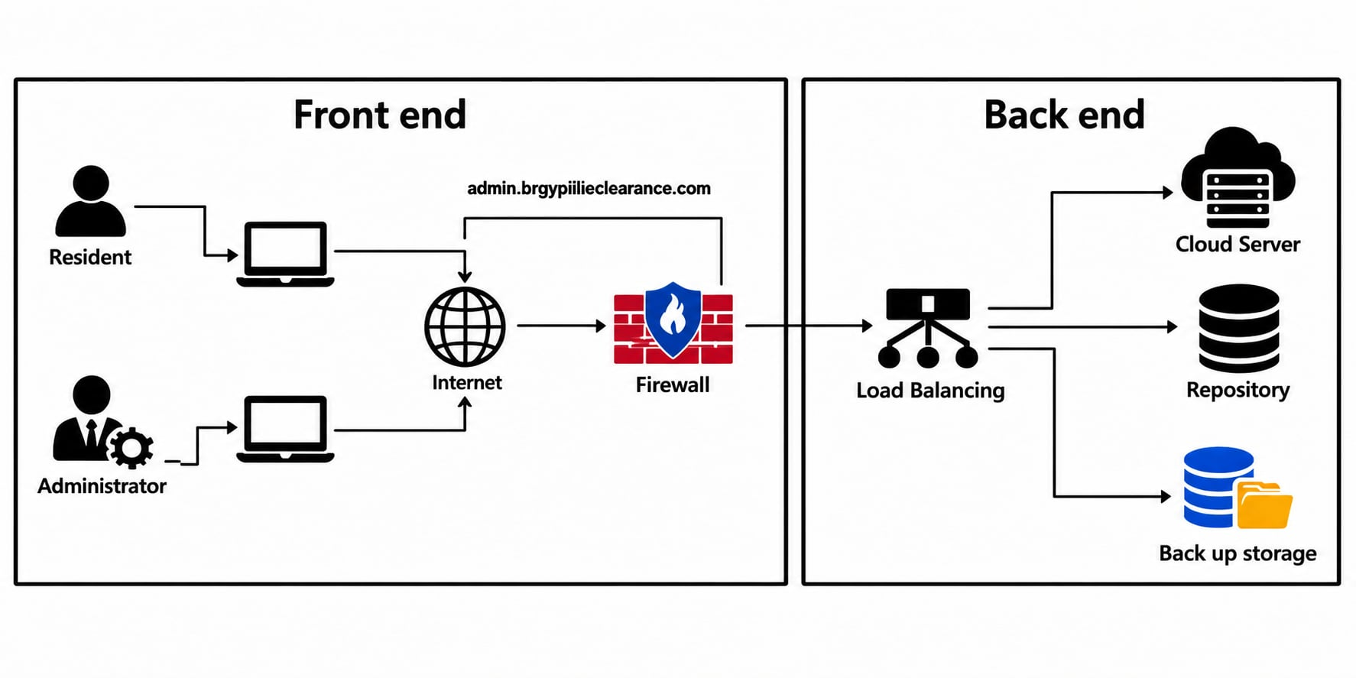
Figure 16. System Architecture
Figure 16 shows the System Architecture of the Barangay Pili Clearance & Records Management System The system adopts a multi-tier architecture consisting of a presentation layer, application layer, and data layer. It provides three main portals: Admin, Staff, and Resident, each with distinct responsibilities. Admins manage user accounts, certificate types, archives, and reports. Staff handle certificate requests, payments, resident records, summons, bulletins, and borrow requests. Residents access services through both web and mobile interfaces, enabling them to request certificates, track progress, borrow equipment, view announcements, and update profiles. The backend architecture integrates a Laravel 9 framework with Blade templating, running on PHP 8 and styled with CSS. A web server connects to a MySQL database containing 12 tables and 14 foreign keys, ensuring relational integrity across requests, payments, residents, and
summons. An SMTP mail service supports notifications, password resets, and OTP verification codes, enhancing system security and communication. The request workflow and print engine manages certificate lifecycles through stages of Pending, Processing, Approved, and Released. Once approved, the system automatically generates documents using official template files, ensuring consistency and compliance with barangay standards. Additional modules include code/token management for verification and document generation for printing approved certificates. This architecture demonstrates a role-based, modular design that ensures accountability, efficiency, and scalability. By combining web technologies, relational databases, and secure communication services, the system provides a comprehensive solution for barangay clearance and records management, streamlining administrative processes while improving accessibility for residents.
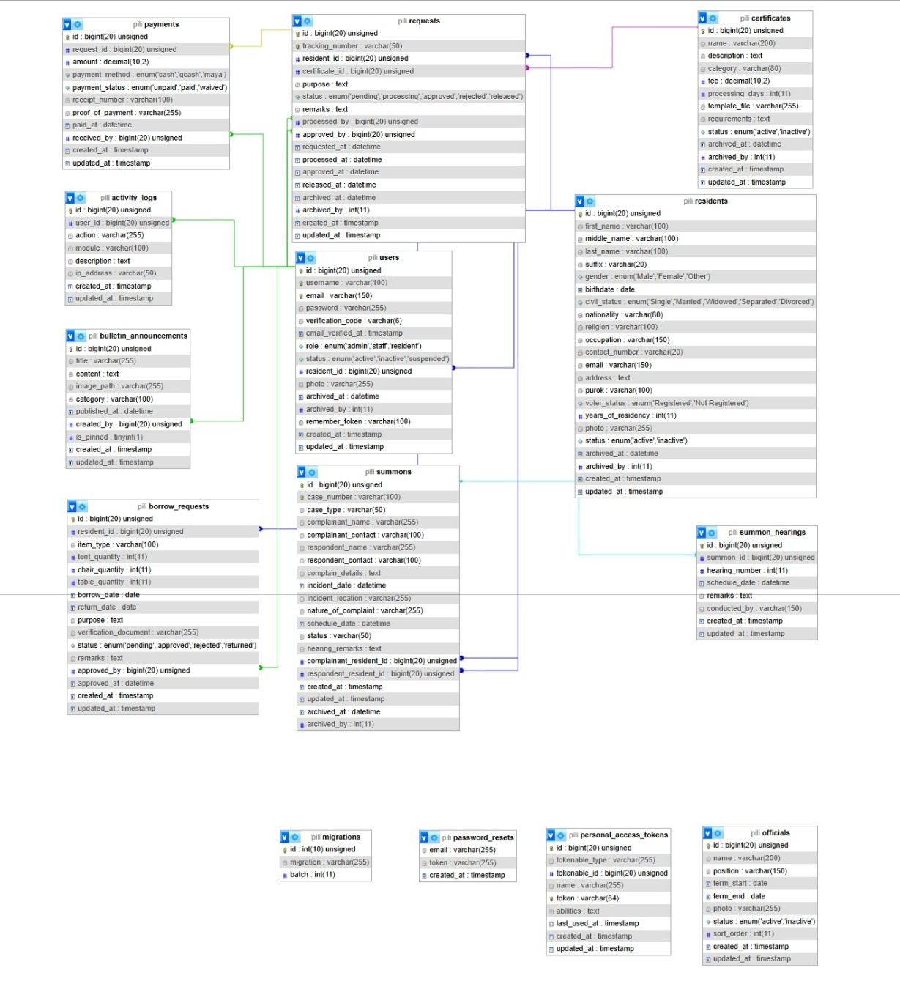

Figure 17. Entity–Relationship Diagram (ERD)
Figure 17 Shows the Entity–Relationship Diagram (ERD) Implementation An Entity–Relationship Diagram (ERD) is a graphical representation of the relationships between entities in an information system. It serves as a blueprint for database design, visually mapping out how data is structured and interconnected. As TechTarget (2024) explains, the ERD illustrates the relationships between individuals, things, locations, ideas, or events within an IT system. Simplilearn (2024) further emphasizes that ERDs are built upon three foundational elements: entities, relationships, and attributes. Core Elements in This ERD Entities (Tables): Residents, Users, Certificates, Requests, Payments, Summons, Officials, Activity Logs, Borrow Requests, Bulletin Announcements, Password Resets, Summon Hearings Each entity represents a real-world concept (e.g., residents in a community, requests for certificates, or payments made). Attributes (Columns): Each table contains attributes such as id, name, status, tracking_number, amount, etc. Primary Keys (PK) uniquely identify records, while Foreign Keys (FK) establish links between related entities. Relationships: One-to-Many: A resident can make multiple requests; a request can have multiple payments. Many-to-One: Each request is tied to a single certificate and processed by a single user. Many-to-Many (via linking tables): Summons connect complainants and respondents (both residents), with hearings scheduled under each summons. Implementation Highlights Residents Requests: Residents submit requests for certificates, tracked by unique numbers. Requests Certificates: Each request corresponds to a certificate type, with associated fees and categories. Requests Payments: Payments are linked to requests, recording method, status, and receiver. Users Activity Logs: System users generate logs of actions performed, ensuring accountability. Summons Hearings: Summons involve residents in disputes, with hearings scheduled and conducted by officials. Officials: Stored independently, representing governance roles without direct foreign key dependencies. Bulletin Announcements: Created by users, serving as community information broadcasts. Password Resets: Standalone entity for account recovery, linked only by email. Structural Design This ERD provides a normalized relational database schema that ensures: Data integrity through PK/FK constraints. Traceability of requests, payments, and summons. Scalability for adding new modules (e.g., community projects, events). Security with user activity logs and password reset tracking.
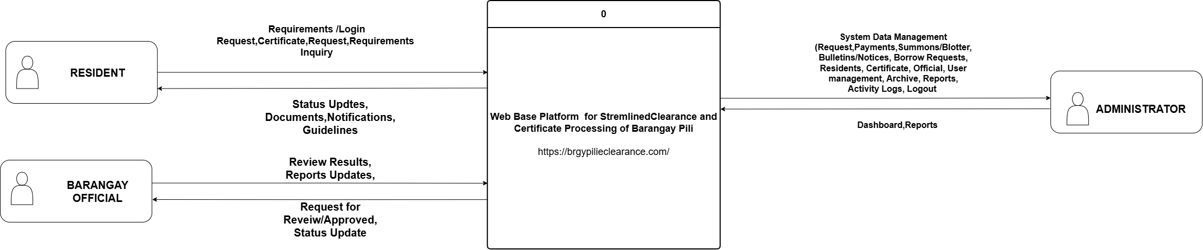Figure 18. Data Flow Diagram
Figure 18 shows the Data Flow Diagram (DFD) of the Barangay Pili Clearance & Records Management System. The diagram illustrates how data flows between the Resident, Barangay Officials/Staff, Administrator, system processes, and data stores. Residents interact with the system by registering and logging in, submitting clearance and certificate requests, providing the required information, and monitoring the status of their applications. Barangay Officials/Staff review and process requests, update request statuses, and facilitate the preparation and release of certificates. Administrators manage user accounts, resident information, certificate types, officials, requests, reports, archives, and other system records.
Data Flow Diagram

